***Search and learn on one of the most interesting topics of the future***

***LT-PBIO-01***

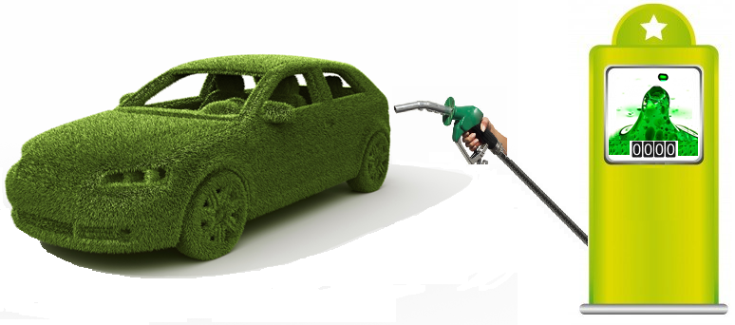

***Discover why the big oil companies are inverting on Algae technology***

*For many years it was consider tat the biomass coming from the vegetables products was a good solution to the complex situation of replacing fossil fuel, How ever XXXXXXXXXXXXXX ……*

*From 2009, new research studies allowed to know that the fuel, obtained from the algae, has more advantages, than those ones derivate from the food, to partially or totally replace fossil fuel.*

*Our biofuel algae production plant is a novedous initiative to allows you to know the algae process and you will understand why it has became the focus of vegetable production.*

*Our plant allows you to do research, education, training and entre entrepreneurship around one of the most interesting technologies.*

******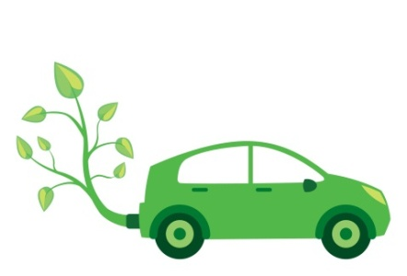

***What is an Algae?***

*The algae are vegetable organisms from the cyanobacteria group which have a very simple structure: without roots, stem or leaves.*

*The algae require CO2, O2 and sun light to achieve its photosynthetic process. They grow in aquatic media or high humidity, no matter if the water is salty or sweet.*

*There are algae from a single all up to multiple cells like the ones of several meters long.*

*The algae contain calcium, potassium, iodine, magnesium, sulfur, iron, manganese, copper, sodium, selenium, sulphur, silicon and molybdenum, etc. because this product allows to obtain wide variety of sub products.*

*Algae’s biomass can be used in the production of oils (for further refinement into biofuel and glycerin) and stable fiber (used in proteinic materials and alcohol).*

***How does this process work?***

*You get a complete plant to produce biofuel from inoculation of algae up to the bio fuel extraction.*

*This “turn key” solution allows you to make algae biofuel, controlling the different process stages and with the opportunity to monitor all the variables. If you are interested in research this plant is one of the best tools.*

***Process Stages***

**Inoculación de Algas**

**Crecimiento**

**Cosechado**

**Separado**

**Centrifugado**

**Prensado**

**Agua Reciclada**

**Agua y nutrientes**

**Aceite de Algas**

**Biocombustible**

**Metanol**

**Glicol**

**Biodiesel**

**Biomasa**

**Alimento para mascotas**

**Proteínas**

**Fermentación**

**Destilación**

**Bioetanol**

**Transesterificación**

*The purple boxes are not part of this equipment*

***Important note:*** *Because of patent issues there are no system diagrams but, according to your interest, this can be discussed with you in private.*

***Sun***

***Co2***

***Water***

***Lipid***

***Carbohydrates***

***Proteins***

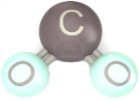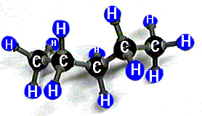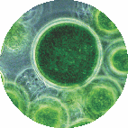

***Algae***

***¿Cómo puede solicitar esta planta?***

1. ***Like a pilot plant .***

*In this kind of plant a control panel allows you to develop control on all the process involved and also allows you to modify the total operation. With the touch scream interface you can make manual or automatic operation of the whole process, observe the variable during the production cycle. You can also diagnose or stop the complete process.*

*A pilot plant is offered to those research or educational professionals who which to focus on the process rather them the individual knowledge of every device used. A very easy, safe and XXX operation is guaranteed to have an easy, safe and reliable operation.*

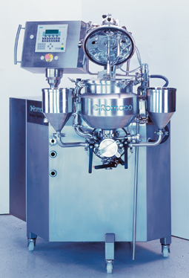

1. ***As a group of control stations.***

*The plant is designed not as a single integrated process but as a set of separate sub process which can operate individually. The involved process variables at every step are wired up to a module or individual panel, where you can make all kind of connectors to our PTS F1616 control system or other control brands.*

*On every control station, each group of students can develop their own control algorithm trough manual, automatic or remote control, operated by PC, PLC or Stand – alone.*

*This is by the best educational option for courses on control, automation, electronics and mechatronics.*

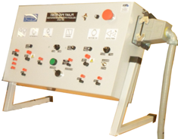*One of the big advantages is that every workstation doesn’t affect the others. This consideration is useful to simultaneously attend more students. At the end of the course, all the group can coordinate to make a complete production run.*

***What is included on this plant?***

***General***

* *Photo bioreactors.*
* *Pumps*
* *Press*
* *Fermenter*
* *Pressure, flow and temperature sensors*
* *Interconnecting piping*
* *Water inlet*

***Pilot plant***

* *Touch scream*
* *Control panel*
* *Data acquisition software*
* *Training for the instructor or research.*

***Educational Process***

* *PTS F1616 control system.*
* *Connection cables*
* *DAQ for every control station.*
* *Four work station*
* *Training for professors*



**LATIN TECH INC.**

**PH: 305 914 5083**

**Fax: 775 637 6825**

**8004 NW 154 ST. # 621**

**Miami 33016, FL, USA**

**Discover and new experience in education and research.**

**More realistic lab practices.**

***Other Products***

* *Climate change Fitotrón.*
* *Algae Biofuel Pilot Plant.*
* *Bioethanol Plant.*
* *Inverter Pendulum.*
* *Speed, position and generation plant.*
* *PLC trainer (Generic, AB, Simens, e.t.c.).*
* *Solar heating system.*
* *Hydrogen cells trainer.*
* *Solar and Eolic energy trainer.*
* *Water supply plant.*
* *Motor-generator plant.*
* *Drives.*
* *SCADA.*
* *Others didactic process (in preparation)*
* *Motor-generador.*
* *Drives.*